| **Test Name** | | | User Can Move From One Sensor To Another | | | |
| --- | --- | --- | --- | --- | --- | --- |
| **Use Case Tested:** | | | Move From One Sensor To Another | | | |
| **Test Description:** | | | The user navigates to a single sensor and then selects another one from the list to the left. | | | |
| **Pre-conditions** | | |  | | | |
| **Post-conditions** | | | The currently displayed window should be that of a different single sensor window | | | |
| **Notes:** | | **Unsure how else to demonstrate a button click other than through screenshots.** | | | | |
| **Result (Pass/Fail/Warning/Incomplete)** | | **Pass** | | | | |
|  | **TEST STEP** | | | **EXPECTED TEST RESULTS** | P | F |
|  | Click On Sensors On Menu | | | All Sensors Window Is Displayed | X |  |
|  | Select A Sensor from either list | | | Single Sensor Is Displayed | X |  |
|  | Select A Different Sensor from the list on the left | | | A New window is displayed showing the expected sensor and data, the old window is closed | X |  |

**Test Output Screenshots**

Start

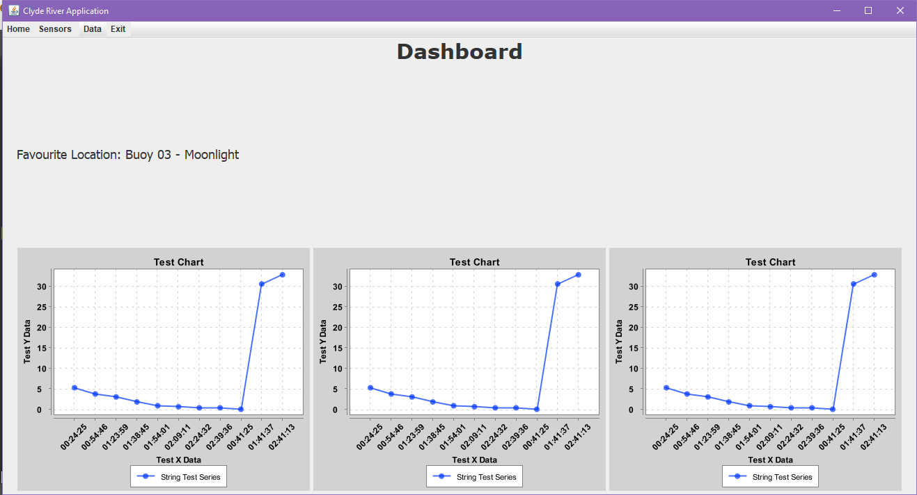

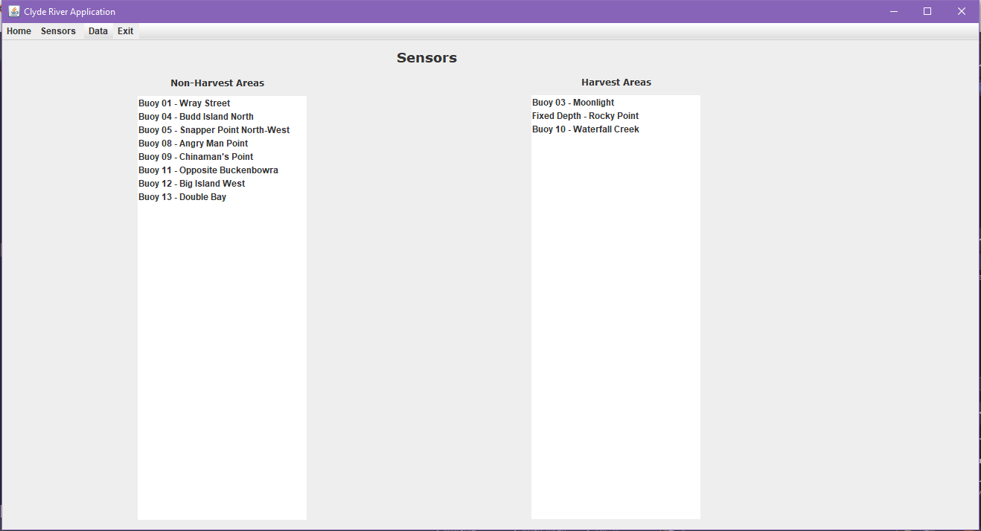

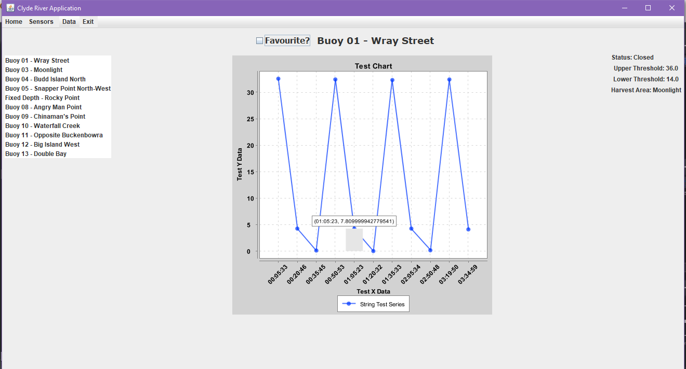

Result

